FOR IMMEDIATE RELEASE

“Perfect entertainment for the whole family.”
—Pete Hammond, Boxoffice.com

FROM THE MAGICAL WORLD OF DISNEY COMES A FAMILY FILM
WITH HEART, HUMOR AND FUN
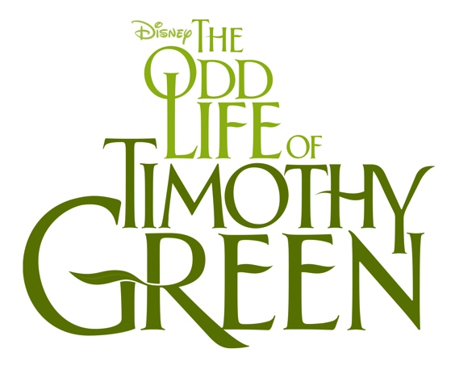
Releases In Full Bloom For the Holidays on Blu-ray™ Combo Pack, DVD, High Definition Digital & On-Demand, December 4, 2012

Burbank, Calif., October 10, 2012—Disney’s “The Odd Life of Timothy Green,” one of the year’s most uplifting and enchanting family films, springs up on Blu-ray™ Combo Pack, DVD, High Definition Digital and On-Demand platforms on December 4, 2012. It’s the perfect, must-own family-film for audiences of all ages to enjoy and snuggle up to this coming holiday season.

From Academy Award-nominated writer/director Peter Hedges (Dan in Real Life, What’s Eating Gilbert Grape), and starring Golden Globe® winner Jennifer Garner, Joel Edgerton, Oscar® winner Dianne Wiest and CJ Adams as Timothy Green, comes this highly imaginative story about a happily married couple who can’t wait to start a family but can only dream about what their child would be like. Then one stormy night young Timothy shows up on their doorstep. Soon they and the small town in which they live learn that sometimes the unexpected can bring some of life’s greatest gifts. The story is written by Ahmet Zappa (“American Gangster,” “Changeling”).

“The Odd Life of Timothy Green” Blu-ray Combo Pack provides viewers with the chance to delve deeper into this captivating movie experience through never-before-seen bonus features, including the documentary “Family Roots: Bringing ‘The Odd Life of Timothy Green’ to the Screen,” which looks at this unique family story and the creative team that brought it to life; “Glen Hansard: Behind ‘This Gift” - the Academy Award® winning songwriter tells how he and Marketa Irglova crafted the moving end-credits song; “This Gift” Music Video by Glen Hansard; Five all-new deleted scenes; and a director audio-commentary.

“The Odd Life of Timothy Green” will be available to own and for in-home viewing and will contain the following bonus features:

BONUS FEATURES | 2-Disc Blu-ray Combo Pack | 1-Disc DVD | HD Digital
Documentary—“Family Roots: Bringing ‘The Odd Life of Timothy Green’ to the Screen”  A look at the telling of this unique family story and the team that made it happen. | X |  | X
“Glen Hansard: Behind ‘This Gift.’”  A look at the Oscar winner and the creation of the poignant end-credits song. | X |  | X
“This Gift” Music Video by Glen Hansard | X | X | X
Deleted Scenes:  - Remembering Bubbles  - Neighbor  - Discovery  - You’re a Fichus  - A Mess | X | X | X
Director Audio Commentary | X

DISC SPECIFICATIONS:
Street Date: December 4, 2012
Direct Prebook: October 9, 2012
Distributor Prebook: October 23, 2012
Release Formats & Suggested 2-Disc Combo Pack = $39.99 U.S./$46.99 Canada
Retail Price: 1-Disc DVD = $29.99 U.S./$35.99 Canada
HD Digital & On-Demand = please check with your local provider or favorite digital retailer for pricing

Feature Run Time: Approximately 100 minutes
Ratings: U.S.: PG / Canada: PG (Bonus material not rated)
Aspect Ratio: Blu-ray: 1.85:1 / DVD: 1.85:1
Audio: Blu-ray: 7.1 DTS-HD / DVD: 5.1 Dolby Digital
Languages & Subtitles: English, French, Spanish

Social Media:
Stay connected with the latest news and information on Disney’s “The Odd Life of Timothy Green”, please visit the following:
- “Like” the Facebook page at https://www.facebook.com/OddLifeMovie
- Follow us on Twitter at @ https://twitter.com/oddlifemovie

About the Cast and Filmmakers:
“The Odd Life of Timothy Green” stars Golden Globe® winner Jennifer Garner (“Arthur,” “Butter”), Joel Edgerton (“Warrior,” “The Thing”), Academy Award® winner Dianne Wiest (“Rabbit Hole,” “Synecdoche, New York,” “I Am Sam”) and CJ Adams (“Dan in Real Life”). Rounding out the cast are Rosemarie DeWitt, Ron Livingston, M. Emmet Walsh, Odeya Rush, Lin-Manuel Miranda, Lois Smith, with David Morse and Common.

Writer/director Peter Hedges adapted his first novel “What’s Eating Gilbert Grape” into the film starring Johnny Depp, Leonardo DiCaprio and Juliette Lewis. Since then, Hedges has written and directed two of his own films, “Pieces of April,” starring Katie Holmes, and “Dan in Real Life,” starring Steve Carell. His adaptation of Nick Hornby’s novel “About a Boy” was nominated for Best Screenplay Academy Award® in 2002. The producers are Emmy® and Tony Award®–winner Scott Sanders (“The Color Purple,” “The Pee-Wee Herman Show”), Ahmet Zappa and Jim Whitaker (“American Gangster,” “Changeling”). Executive producers are John Cameron (“Lars and the Real Girl,” “Fargo”) and Mara Jacobs. Peter Hedges penned the screenplay from a story by Ahmet Zappa.

The production team also includes double Academy Award®–winning cinematographer John Toll (“The Adjustment Bureau”), production designer Wynn Thomas (“Get Smart,” “A Beautiful Mind”), costume designer Susie DeSanto (“13 Going On 30,” “White Oleander”) and Academy Award®–nominated editor Andrew Mondshein (“What’s Eating Gilbert Grape,” “Chocolat”).

About The Walt Disney Studios:
For more than 85 years, The Walt Disney Studios has been the foundation on which The Walt Disney Company was built. Today, the Studio brings quality movies, music and stage plays to consumers throughout the world. Feature films are released under the following banners: Disney, including Walt Disney Animation Studios and Pixar Animation Studios; Disneynature; Marvel Studios; and Touchstone Pictures, the banner under which live-action films from DreamWorks Studios are distributed. The Disney Music Group encompasses the Walt Disney Records and Hollywood Records labels, as well as Disney Music Publishing. The Disney Theatrical Group produces and licenses live events, including Disney on Broadway, Disney On Ice and Disney Live!.

These press materials are available in electronic form at www.WDSHEpublicity.com

# # #
© 2012 Disney
MEDIA CONTACTS:
Broadcast: Maria Barraza Regional: Marilyn Hsiung Print: Darrell Borquez Online: Gabrielle Bilicki
818-560-4068 818.560-4099 818-560-4073 818-560-4069
Maria.Barraza@Disney.com Marilyn.R.Hsiung@disney.com Darrell.Borquez@disney.com Gabrielle.Bilicki@disney.com

